Add two methods.

1. Auto Complete input (only City Name in Index.php)

Using Bloodhound and typeaheadJS.

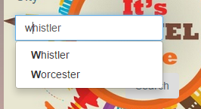

2. Enter Captcha when user want to register new user.

Using PHP image function.

